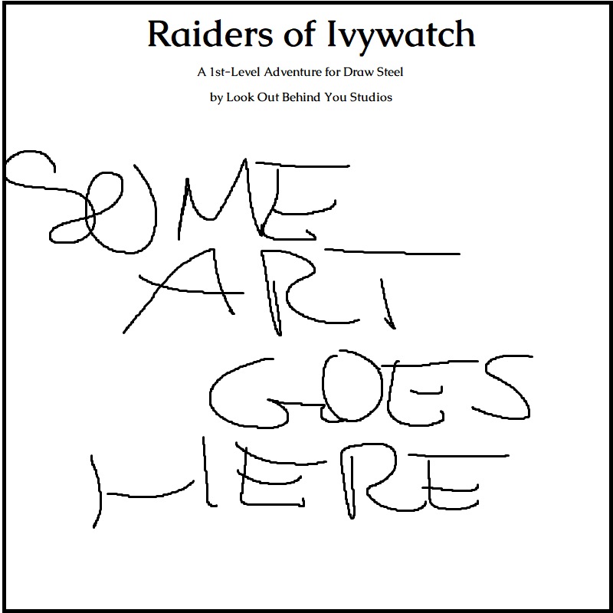
Cover Art by Jaelani36

“Raiders of Ivywatch” is an independent product published under the DRAW STEEL Creator License and is not affiliated with MCDM Productions, LLC. DRAW STEEL © 2025 MCDM Productions, LLC.

Raiders of Ivywatch © 2025 Look Out Behind You Studios LLC


Raiders of Ivywatch
Raiders of Ivywatch is an adventure set in Vasloria, a woody, humid, and vaguely Europe-like region of Orden. The adventure is designed for two to seven 1st-level heroes and grants between 10 and 18 Victories.

Adventure Background
Ajax orders the Hawklords to steal the Sealing Stone from Ivywatch and bombard the town. Lizardfolk in the area seize the opportunity to raid the razed town and take citizens back to their fortress lair, as food and as sacrifices to their evil reptile god. With the Sealing Stone stolen, long held-shut portals to Arcadia open wide, letting anything through…

Synopsis
The heroes escort a merchant to Ivywatch and stumble into lizardfolk up to no good. They can pursue the lizardfolk to a nearby cave or go straight to Ivywatch as its still being raided. The heroes are tasked with saving the stolen citizens from the lizardfolk holed up in a nearby fortress. The heroes meet and potentially negotiate with a squire to knights battling against forces of evil in Arcadia, then battle Deatheye Yslansh and the deity she summons, Excrucior Interfectus.

Adventure Hook
The following adventure hook leads the heroes into the Prologue of Raiders of Ivywatch.
Guards for Hire: The heroes accompany a merchant who has hired them for protection along the wooded road to Ivywatch, promising coin and political connections as a reward.
If the heroes arrive in Ivywatch for their own reasons, go straight to the town (Part 1B). The following hook can be used to lead the players to Ivywatch.
Distant Assault: The heroes see Ajax’s Hawklords carrying their notoriously destructive iron orbs. Wherever the Hawklords are taking those, there are likely to be people in need of heroic assistance.
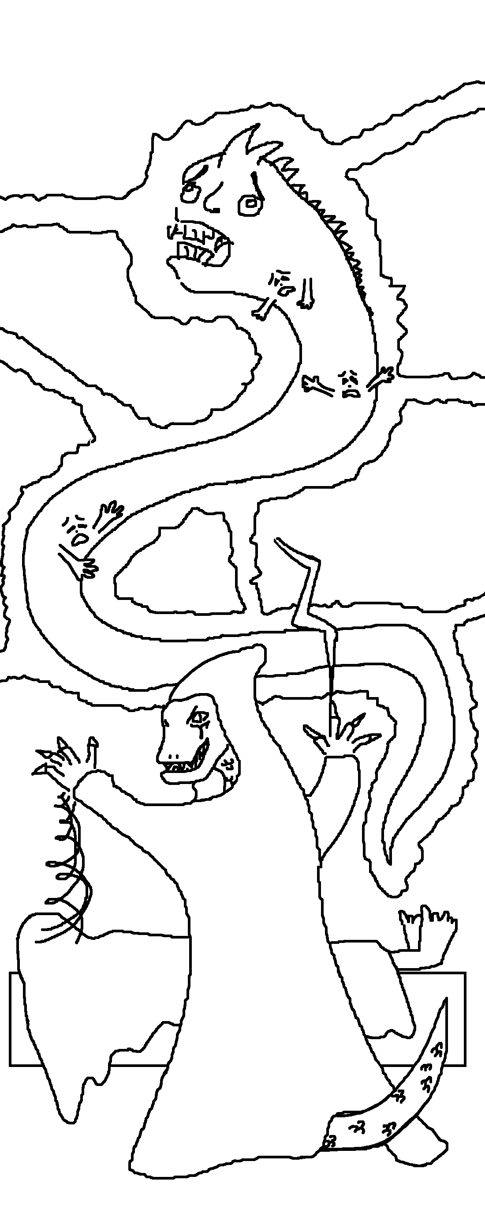
Deatheye Yslansh summons Excrucior Interfectus

Prologue: Ambush
You’ve spent the last few days following the King’s Road to Ivywatch, walking alongside the wagon of your employer, a blond, spectacle-wearing, fidgety polder merchant named Lewin Coppertoe.
Should Mr. Coppertoe and all of his cargo make it safely to Ivywatch, you will be paid the rest of the agreed upon amount and he promises to put in a good word for you with his cousin, the steward to the lord of Ivywatch.
Boxed, italicized text like this is meant to be read aloud to your players!

Take a moment to do the following:
- Encourage the players to introduce their heroes if they haven’t already.
- The heroes are each well-known in some region if not this one. Ask which exploits the bards sing of each of them the most.
- Ask the players how their Heroes each spend evenings in camp while on the road.
- Ask the players what their heroes’ marching order is while traveling. Mr. Coppertoe drives the wagon. The heroes are expected to not ride the wagon, but whether each of them walks alongside, scouts ahead, brings up the rear, or otherwise is up to them.
The sun is high, filtering through the canopy of trees stretching over the road. The terrain is more hilly today, the road winding between embankments.
Low ground and surrounded by blind spots…
You round a corner and the path is blocked by two felled trees right in front of a bridge. Another wagon lies broken in a ditch. Dried blood covers the road. You hear chittering around you in the forest. Exactly as you anticipated, it’s an ambush!


Lewin Coppertoe

Draw Steel! “Blocked Bridge”
Lizardfolk ambush the heroes and their employer.
Earn 1 Victory for ending the threat while keeping Mr. Coppertoe alive.

Movement
- Squares with a tree grant cover (whether on the ground or in the tree).
- Squares with any amount of tall grass count as difficult terrain and grant concealment.
- While in a full tile of water, use the “Underwater Combat” rules: fire immunity 5, lightning weakness 5, and if your speed doesn’t have the Swim keyword, all your power rolls take a bane.

Height
- The water is 1 square deep.
- Standing trees are 2 squares high for the purposes of climbing and jumping from.
- Fallen trees are 1 square high for the same.

Encounter
The heroes, the wagon, and Mr. Coppertoe all begin in the box marked “START.” The positions of each enemy in Squad A are immediately detectable, all other enemy forces start concealed.
Party Size | Location | Enemy Forces:  Lizardfolk
2 | Ridge  Bridge  Water | Squad A: 1 Bloodeye  Squad B: 5 Tonguers (m)  Squad C: 5 Tonguers (m)
4 | Ridge  Bridge  Water | Squad A: 2 Bloodeyes  Squad B: 5 Tonguers (m)  Squad C: 5 Tonguers (m)  Squadless: 1 Scaletooth
* for unlisted party sizes, add 1 Bloodeye (Water – Squadless) per extra member over a listed party size.

Tactics
The tonguers can pull the heroes into the water, where their power rolls have banes. The bloodeye can attack from high ground, where it has an edge. If the heroes are tanky (30+ Stamina) or the players are confident, assign the minion squads captains.
If you ignore the reference map and instead start the party on the bridge, the encounter is much harder, as the lizardfolk have more angles to pull the heroes into the water from and more high ground to attack them from within range.

Ambush Averted
The lizardfolk slain, the scene becomes more obvious upon inspection. It looks like bodies were dragged from the wagon with resistance into the forest.
Mr. Coppertoe asks that the heroes clear the road, ignore the scene, and continue with him to Ivywatch. But there might still be people in need of help…

Mr. Coppertoe warns, a nervous quiver in his voice:
“Allow me to courteously remind you: if any one of you leave, the contract is broken and the reward is forfeit. And my cousin would be very disappointed!”

If the heroes choose to follow the tracks through the woods, they have no trouble (no skill tests needed). Continue the adventure with Part 1A: The Cave.
If the heroes choose to accompany Mr. Coppertoe and his goods all the way to Ivywatch, continue the adventure with Part 1B: The Town.

Part 1A: The Cave
You follow the trail through the forest with ease. The obvious tracks suggest a struggle.
Maybe the abductees still live!

Scenes
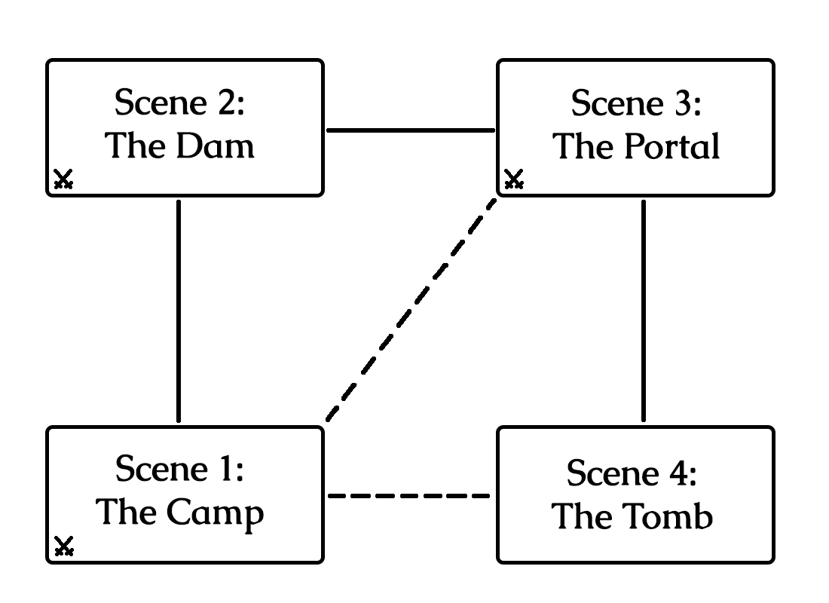

Players should always know exactly what the conditions are to earn Victories in each encounter in this adventure. Just read it aloud before they draw steel.
Generally, it’s better that the players clearly understand which enemies are minions (“these ones look particularly frail and untrained”) and which are captains commanding minions (“they seem to listen to the orders of this one”).

